# 1. Introduction

The evaluation of medical imaging systems is a major problem in diagnostic radiology. Receiver operating characteristic (ROC) analysis is widely used in the evaluation. The method is asking readers (observers) to give ratings to images for their confidence of lesion existence without knowing the truth. Higher ratings usually means higher confidence that there are lesions in the image. Then the ratings are used to calculate true positive fraction (TPF) and false positive fraction (FPF). The ROC curve is defined by the points of the sensitivity (aka TPF) versus specificity (aka 1 - FPF). There are several statistical methods available for multi-reader multi-case (MRMC) ROC analysis with different figures of merit. The DorfmanBerbaum-Metz (DBM) algorithm is the first published and most widely used method for MRMC ROC analysis. It reports a p-value of the statistical test of the null hypothesis (NH) that the modalities are actually identical. Besides DBM method, there are at least five more approaches to the MRMC ROC study. They are (1) Obuchowski and Rockette’s ANOVA approach; (2) Toledano and Gatsonis’ ordinal regression methodology; (3) Song’s analysis of correlated ROC areas in diagnostic testing; (4) Ishwaran and Gatsonis’ hierarchical ordinal regression models; (5) the Beiden-Wagner-Campbell (BWC) multiple-bootstrap method.

Software implementation availability for these methods are given in table 1. Following is the brief descriptions of the available softwares.

* OR-DBM MRMC is designed by the Medical Image Perception Laboratory of the University of Iowa. OR and DBM method are implemented and unified for MRMC ROC Table 1: Software availability of MRMC ROC analysis methods

|  |  |
| --- | --- |
| Algorithm | Online Downloadable Softwares |
| Dorfman-Berbaum-and Metz (DBM) | OR-DBM MRMC, JAFROC, iMRMC |
| Obuchowski and Rockette (OR) | OR-DBM MRMC, JAFROC, iMRMC |
| Toledano and Gatsonis | None |
| Song | None |
| Ishwaran and Gatsonis | None |
| Beiden-Wagner-Campbell (BWC) | None |

analysis. The area under ROC curve (AUC), partial area under ROC curve (pAUC), the sensitivity at specified specificity, and the specificity at specified sensitivity are used as figures of merit in the analysis. Four ROC curve estimation methods are implemented in the program, which are RSCORE, contaminated binormal method (CBM), PROPROC and the trapezoidal/Wilcoxon method. Trapezoidal/Wilcoxon method calculates the empirical estimation of AUC while the other methods fit the ROC curve using distributional assumptions with different parameters.

* JAFROC, an acronym for *j*ackknife *a*lternative *f* ree-response *r*eceiver *o*perating *c*haracteristic, is a free software applicable to the planning and analysis of FROC studies. The software is developed by Dr. Dev Chakraborty, Dr. Hong-Jun Yoon and Xuetong Zhai. For ROC data, JAFROC performs MRMC analysis using DBM method with AUC figure of method. Empirical estimation of AUC is computed using trapezoidal/Wilcoxon method, while no curve fitting method is included. JAFROC has the capability to analyze data accounting for localization and multiple lesions per image, which is described in section 4.
* iMRMC is a Java-based software. It is an open source project under the management of Dr. Brandon Gallas, Dr. Xin He and Rohan Pathare who are from US Food and Drug Administration. It estimates the variance components that are used in methods besides DBM and OR, including BDG, BCK and MS variance components. Hypothesis testing and confidence interval on the difference of two modalities are calculated using t-statistic with corresponding degrees of freedom. Similar with JAFROC, iMRMC also only selects AUC as the figure of merit, and estimates empirical AUC with trapezoidal/Wilcoxon method.

All of these three softwares are GUI (graphical user interface)-based, so it is difficult to call functions or grab the results from other program. But this is important for users with programming requirements. It is absolutely unreasonable to let users run softwares manually and copy the result to their own code every time. Considering R is widely used in statistic and data analysis, it is necessary to develop an R package with the capability to perform MRMC ROC analysis. Firstly, R users will be able to call functions in the package from their programs. Since all R packages are open source and R is a“higher”level language, users have the possibility to debug and modify the source code to satisfy their requirements without complicated programming skills. In addition, thanks to the amazing extensibility of R, packages will be available to be called from other languages, including C/C++, Python, Java and MATLAB, on all major platforms. Therefore, we developed the package JAFROCwR (JAFROC within R) to make the analysis easy and convenient, which implements all features in JAFROC. The package is available to download from the Comprehensive R Archive Network at http://CRAN.R-project.org/package=JAFROCwR. Table 2 shows a brief comparison of the three softwares and the package JAFROCwR.

Table 2: Softwares comparison

|  |  |  |  |  |
| --- | --- | --- | --- | --- |
| Softwares | OR-DBM MRMC | JAFROC | iMRMC | JAFROCwR |
| Data Input | Plain text | Excel file | Plain text | Both |
| Open Source/Language | No/C++ | No/C++ | Yes/Java | Yes/R |
| Cross Platforms | No | No | Yes | Yes |
| Call from Other Languages | No | No | No | Yes |
| ROC Curve Fitting | Yes | No | No | No |
| Localization | No | Yes | No | Yes |

This paper is organized as follows. The statistical model and method used in the package JAFROCwR are introduced in Section 2. Section 3 includes examples of the use of the package and analysis results of a same dataset from the package and other softwares. Localization issue and other additional features are shown in 4. Limitations and potential future updates is discussed in Section 5. Finally, the conclusions are described in Section 6.

# 2. Statistical Models and Methods

In the ROC paradigm the observer’s task is to assign a single rating to each case (which could be a single image or multiple images from the same patient). The ratings are actually *ordered labels*. For example, in a ratings task with 5 discrete levels, the ratings could be the labels “1”: definitely non-diseased, “2”: probably non-diseased, “3”: could be non-diseased or diseased, “4”: probably diseased, “5”: definitely diseased. Each image is indexed by , where is the truth state index (1 for disease-free cases and 2 for diseased cases) and  indexes the cases with truth state , specifically,  and where is the number of non-diseased cases and is the number of diseased cases. Let  denote the (random variable) rating given to case by the *j*th reader using the *i*th modality, where *i = 1, 2, ..., I* and *j = 1 ,2, ..., J*, where *I* is the number of modalities and *J* is the number of readers. While other performance measures are possible, in this paper we focus on the trapezoidal area under the ROC curve, , estimated for reader *j* in modality *i*, by the Wilcoxon statistic  defined as follows:



The Wilcoxon statistic yields the empirical probability that diseased images are rated higher than the non-diseased images for the particular modality-reader combination under consideration. It is equivalent to the trapezoidal area under the ROC curve (ref).

## **2.2. DBM model**

We assume fully paired (or fully crossed) interpretations, i.e., each reader interprets each case in each modality. The DBM (DORFMAN, BERBAUM, and METZ 1992) method uses a linear model for the jackknife-derived pseudovalues of , denoted ** for modality *i*, reader *j* and case *k* (where *k* = 1, 2, ..., *K* and *K* = *K1* + *K2* is the total number of cases), defined by:



Here **is the estimate of  for modality *i*, reader *j*, with the rating of case *k* removed from the analysis. Hillis has defined a normalizing transformation



While this transformation is unnecessary if one uses the Wilcoxon as the figure-of-merit, for generality with other possible figures of merit choices, *it is understood that all calculations from now on will use the centered pseudovalues*.

The DBM pseudovalue model is:



The right hand side consists of 2 fixed effects,  and 6 random effects modeled as mutually independent samples from zero-mean normal distributions with variances specified as below:



Using the dot symbol to denote an average over the corresponding index, the first term  can be estimated by averaging the observed left hand side over all three indices:



To estimate the modality effect one takes the difference as shown below:



It follows that the reader and case averaged difference between two modalities *i* and *i'* is given by



Estimating the strengths of the random terms is a little more complicated. It involves analysis of variance (ANOVA) methods specially adapted to this problem. Only the final results are summarized here. In the following definitions the Y subscript emphasizes that the relevant mean-square (MS) quantities are calculated using pseudovalues, not figure-of-merit values.



DBM, with modifications suggested by Hillis, propose the following test statistic for testing the null hypothesis of no modality effect:



Hillis (ref) has shown that this statistic is distributed as an F-statistic with numerator degrees of freedom *ndf = I - 1* and  denominator degrees of freedom, defined below:





### Decision rule, p-value and confidence interval

The critical value of the F-statistic for rejection of the null hypothesis is given by . The p-value of the test is the probability, under the NH, that an equal or larger value of the F-statistic than  could be observed by chance. In other words, it is the area under the (central) F-distribution that lies above the observed value:



Hillis has shown that the percent confidence interval for  is given by



The averages indicated by the dot symbols are over the reader index. Here is that value such that  of the central t-distribution with degrees of freedom lies above it:



Three completely equivalent rules could be adopted to reject the NH: (1) , (2)  and (3) excludes zero.

The analysis described so far treats both readers and cases as random factors, so it is termed random-reader random-case (RRRC) analysis. Special cases of the analysis, which regards either readers or cases as fixed factors, is possible, and the results are given in the appendix.

## **2.3. The OR model**

Unlike DBM, OR model the figure of merit, not the pseudovalues. The OR model for fully-crossed interpretations is:



[Note: while there is a notational clash as some of the same symbols are being used in the DBM and OR models, removing this ambiguity would create unnecessarily complex notation, since the meaning will be obvious from the context. For example all symbols in the OR model refer to figure of merit derived quantities, whereas all symbols in the DBM model refer to pseudovalue derived quantities.]

The left hand side of Eqn. xx is the estimated Wilcoxon figure-of-merit for modality *i* and reader *j* and case set index {*c*}, where *c* = 1, 2, …, *C* denote different case sets, i.e., different collections or sets of randomly sampled cases, each with  non-diseased and  diseased cases. In practice one is limited to datasets with *c* = 1, so techniques, some involving resampling methods, have been developed to tease out the case-sample dependence from a single dataset.

The first two terms on the right hand side have their usual meanings (average figure of merit over all readers and modalities and the modality effect, respectively). The remaining terms are mutually independent random samples as follows:



The error term is modeled by a multivariate normal distribution with zero-mean vector (with length *IJ*) and covariance matrix  (with dimension *IJ x IJ*). In other words,



The covariance matrix  is defined by 4 parameters, , defined as follows:



In practice the OR covariance matrix can be estimated using the jackknife, the bootstrap, DeLong’s method, or parametric methods. The DeLong method is restricted to the Wilcoxon statistic, i.e., Eqn. xx, but the other methods have more general validity.

### The jackknife method

In the jackknife method (Efron and Stein 1981) one calculates , i.e., the Wilcoxon statistic with case *k* deleted. The jackknife estimates of the covariance matrix terms are as follows (it is understood that primed and unprimed indices are always different):



The right-hand-side of Eqn. xx does not have modality or reader indices, i.e., in the OR model the variance and covariance terms are modeled as modality and reader independent. Therefore, the observed co-variances need to be averaged over all appropriate combinations of modalities and readers. As an example,  needs to be averaged over all combinations of different modalities (*ii'*) and different readers (*jj'*) , as denoted by .

### The bootstrap method

In the bootstrap method (Efron and Stein 1981) one calculates , i.e., the Wilcoxon statistic for the *b*th bootstrapped set of cases denoted *{b}*. The bootstrap estimate of the covariance matrix is:



The bootstrap most closely follows the definition of the covariance matrix if one had the luxury of interpretations on a large number of independent case sets {*c*}. For example, with a total of C independent case sets, the estimate of the variance would be



### The DeLong method for estimating the covariance matrix

DeLong, DeLong, and Clarke-Pearson (1988) have described a non-parametric method for estimating the covariance between two Wilcoxon statistics that are based on the same cases. Define the structural components

|  |  |
| --- | --- |
|  | A1 |

Also define the *IJ* x *IJ* matrix such that the *ij,i'j'* element is given by



And similarly such that the *ij,i'j'* element is given by



In matrix notation, the covariance between  and  can be estimated using (S is the covariance matrix):



Specifically,



The expected ordering of these terms is:



Because of the correlated structure of the error term a customized ANOVA is needed. One starts with the null hypothesis that the true figure-of-merit of all modalities are identical, i.e.,



Because of the correlated nature of the covariance matrix, a modified F-statistic is needed, denoted  defined by:



Eqn. xx incorporates Hillis’ modification of the original OR proposal, which ensures that the constraint is always obeyed. The relevant mean square terms are defined by (note the lack of the Y subscript, as these are calculated directly using FOM values)



In their original paper OR state (ref) that their proposed test statistic F* (basically Eqn. xx without the constraint implied by the max() function) is distributed as an F statistic with *ndf = (I-1)* and *ddf = (I-1)(J-1)*. It turns out that with the choice for ddf, the test is unduly conservative. The following *ddf* value, proposed by Hillis, corrects this problem:



The observed statistic  is assumed distributed as an F-statistic with *ndf = (I-1)* and degrees of freedom:



### Decision rule, p-value and confidence interval

The critical value of the F-statistic for rejection of the null hypothesis is given by . The p-value of the test is the probability, under the NH, that an equal or larger value of the F-statistic than  could be observed by chance. In other words, it is the area under the (central) F-distribution that lies above the observed value:



The percent confidence interval for  is given by



## **2.4. Sample Size Calculation**

If a non-significant result is obtained (i.e., *p > α*) then the investigator may wish to estimate, from the observed variability of the data, how many cases and readers would be needed to achieve a given probability (typically chosen to be 80%) of detecting a specified difference (termed effect size) between the modality FOMs in a subsequent study. This is termed sample size calculation. A procedure for sample size estimation for ROC analysis is described in Ref. xx. Briefly, we can calculate the statistical power with OR components via following steps (Hillis, Obuchowski, and Berbaum 2011). All OR components used are defined in the subsection 2.3.

*Specify the effect size.* Let *d* denote the effect size that is the absolute value of the difference of two figures of merit (the two reader averaged Wilcoxon statistics, one per modality). The effect size is defined by  .

2. *Estimate OR parameter.* The variance of modality by reader interaction term in the OR model can be estimated by



3. *Estimate the noncentrality parameter and the degrees of freedom*. Let *K*∗ denote the number of cases in current analysis, and let *J* and *K* be the numbers of readers and cases, which will be used to calculate the statistical power. The noncentrality parameter ∆ and the degrees of freedom ofˆ *FOR*’s denominator is estimated by



∆ =ˆ

and

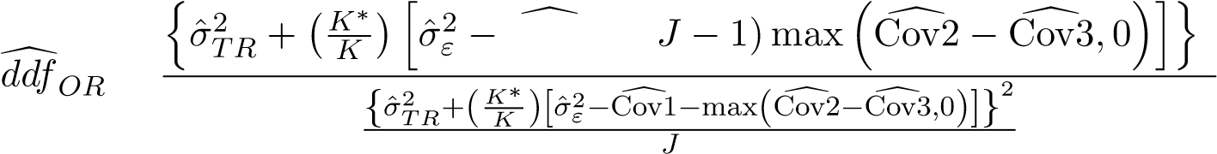2

Cov1 + (

=

−1

The statistical power  at significance level  can be calculated using:



To estimate the sample size for ROC analysis, we usually select a fixed number of readers (or cases) and calculate the statistical power by incrementing the number of cases (readers, vice versa) until the calculation result reaches the desired power. The number of readers and cases combination is a required sample size.

# 3. Examples and Results Comparisons

In this section, some examples of the usage of the package JAFROCwR are shown, and the analysis results of JAFROCwR and other softwares mentioned in Section 1 are provided and compared. The example dataset comes from Carolyn Van Dyke, MD (Van Dyke, White, Obuchowski, Geisinger, Lorig, and Meziane 1993). There are 45 diseased cases and 69 nondiseased cases in the dataset. Five radiologists (reader 0 to 4) read these images using two modalities (modality 0 and 1) and give their ratings for each case.

## **3.1. Analyze the Example Dataset Using** JAFROCwR

The first steps are loading the package and read the data file.

> #library(JAFROCwR)

> dataVanDyke <- readJAFROC("VanDyke.xlsx")

Then we analyze the data using both DBM and OR method.

> resultDBM <- DBMAnalysis(data = dataVanDyke, analysisFOM = "ROC", alpha = 0.05)

> resultOR <- ORAnalysis(data = dataVanDyke, analysisFOM = "ROC", alpha = 0.05,

+ covEstMethod = "Jackknife")

Following is an example of the plotting feature of this package. Figure 1 is the empirical ROC curves of each individual reader and their average performance using modality 0, which is plotted using following code.

> rocCurveM1 <- plotROC(data = dataVanDyke, plottingModalities = 1,

+ plottingReaders = list(1, 2, 3, 4, 5, c(1:5)),

+ legendPosition = "bottom")

> rocCurveM1$ROCPlot

The function for sample size calculation with effect size = 0.05 and desired power = 0.8 are as follows. Result can be found in table

> calculateSampleSizeForData(data = dataVanDyke, alpha = 0.05,

+ Effect_Size = 0.05, Desired_Power = 0.8)

All the results of these example codes are summrized in subsection 3.2. For more information and example, such as the meaning of each parameters and return varables, please read the help documentation at the page of JAFROCwR [http://CRAN.R-project.org/package= JAFROCwR.](http://CRAN.R-project.org/package=JAFROCwR)

## **3.2. Results Comparison**

Analysis results of the same dataset used in subsection 3.1 by other ROC softwares are compared in this subsection. AUC is selected as the figure of merit. DBM method or OR

0.00

0.25

0.50

0.75

1.00

0.00

0.25

0.50

0.75

1.00

FPF

TPF

M−0

R−0

M−0

R−1

M−0

R−2

M−0

R−3

M−0

R−4

M−0

R−0 1 2 3 4

Figure 1: Plots of empirical ROC curves of each reader and their average performance using modality 0

method using jackknife estimation is used for the analysis. JAFROCwR includes functions that save JAFROC data using formats of other softwares. Users can use these functions to convert data between different formats. JAFROC is omitted since the package JAFROCwR produces identical results. Table 3 shows the AUC calculation result of the three softwares. From the values in the table, we can see that AUC calculations of the three different wares are exactly identical.

Table 3: AUC calculation comparison for the dataset “Van Dyke” (“M” and “R” in column and row names indicate “Modality” and “Reader” respectively. Hereinafter the same.)

|  |  |  |  |  |  |  |  |  |
| --- | --- | --- | --- | --- | --- | --- | --- | --- |
|  | OR-DBM MRMC | | | iMRMC | | | JAFROCwR | |
|  | M - 0 | M - 1 | M - 0 | | M - 1 | M - 0 | | M - 1 |
| R - 0 | 0.9196 | 0.9478 | 0.9196 | | 0.9478 | 0.9196 | | 0.9478 |
| R - 1 | 0.8588 | 0.9053 | 0.8588 | | 0.9053 | 0.8588 | | 0.9053 |
| R - 2 | 0.9039 | 0.9217 | 0.9039 | | 0.9217 | 0.9039 | | 0.9217 |
| R - 3 | 0.9731 | 0.9994 | 0.9731 | | 0.9994 | 0.9731 | | 0.9994 |
| R - 4 | 0.8298 | 0.9300 | 0.8298 | | 0.9300 | 0.8298 | | 0.9300 |

Variance and covariance components estimation are given in table 4. The results of iMRMC are slightly different from the other two softwares. The reason is DBM and OR components are obtained through the linear combination of the BDG components instead of the original proposed estimation methods in iMRMC (Brandon D. Gallas 2014).

Table 5 shows the result of the null hypothesis that there is no modality effect. Confidence interval of the difference between the AUC of modality 0 and modality 1. iMRMC did not Table 4: Variance Components Comparison (Letters between the brackets indicate the source of variance. Covariances are defined in 2.3)

|  |  |  |  |
| --- | --- | --- | --- |
|  | OR-DBM MRMC | iMRMC | JAFROCwR |
| DBM Components  Var(R) | 1.5350E-03 | 1.5365E-03 | 1.5350E-03 |
| Var(C) | 2.7249E-02 | 2.6860E-02 | 2.7249E-02 |
| Var(T*R) | 2.0040E-04 | 1.2090E-02 | 2.0040E-04 |
| Var(T*C) | 1.1975E-02 | 2.0776E-04 | 1.1975E-02 |
| Var(R*C) | 1.2265E-02 | 1.1793E-02 | 1.2265E-02 |
| Var(T*R*C) + Var(Error) | 3.9972E-02 | 3.9133E-02 | 3.9972E-02 |
| OR Components  Var(R) | 1.5350E-03 | 1.5365E-03 | 1.5350E-03 |
| Var(T*R) | 2.0040E-04 | 2.0776E-04 | 2.0040E-04 |
| COV1 | 3.4661E-04 | 3.4167E-04 | 3.4661E-04 |
| COV2 | 3.4407E-04 | 3.3906E-04 | 3.4407E-04 |
| COV3 | 2.3903E-04 | 2.3561E-04 | 2.3903E-04 |
| Var(Error) | 8.0229E-04 | 7.8839E-04 | 8.0229E-04 |

test the null hypothesis. so the F value for iMRMC is not available. It gives the confidence interval and the statistics that are used to estimated the confidence interval. The results of iMRMC are still different from the others’ due to the same reason.

Table 5: Main Null Hypothesis Testing and Confidence Interval

|  |  |  |  |  |
| --- | --- | --- | --- | --- |
|  | F value | ddf | p-vlaue | 95% CI of modality 0 - 1 |
| Random Readers Random Cases  OR-DBM MRMC | 4.46 | 15.26 | 0.0517 | (-0.08796 , 0.00036) |
| iMRMC | — | 15.03 | 0.0556 | (-0.0879 , 0.0003) |
| JAFROCwR | 4.46 | 15.26 | 0.0517 | (-0.08796 , 0.00036) |
| Fixed Readers Random Cases  OR-DBM MRMC | 5.48 | 113 | 0.021 | (-0.08088 , -0.00672) |
| JAFROCwR | 5.48 | 113 | 0.021 | (-0.08088 , -0.00672) |
| Random Readers Fixed Cases  OR-DBM MRMC | 8.7 | 4 | 0.042 | (-0.08502 , -0.00258) |
| JAFROCwR | 8.7 | 4 | 0.042 | (-0.08502 , -0.00258) |

Figure 2 is the empirical ROC curves plotted by iMRMC and OR-DBM MRMC. Figure 3 are the fitted ROC curves using CBM (Dorfman, Berbaum, and Brandser 2000; Dorfman and Berbaum 2000a,b), PROPROC (Metz and Pan 1999; Pan and Metz 1997; Pesce and Metz 2007) and RSCORE (Dorfman and Alf 1969; Dorfman and Berbaum 1995) methods. Among these three softwares, only OR-DBM MRMC gives fitted ROC curves. Compare figure 1 and

figure 2, all of them provides identical ROC curves. Figure 2a and 3 are obtained by plotting the output points of OR-DBM using Excel, which is not convenent. In contrast, iMRMC only gives a plot of ROC curves. Re-plotting the curves using other tools or any changes to the plot (i.e. color, line type) are not allowed. Considering these two conditions, JAFROCwR plotting function returns both of the plot of ROC curves and the corresponding points data.

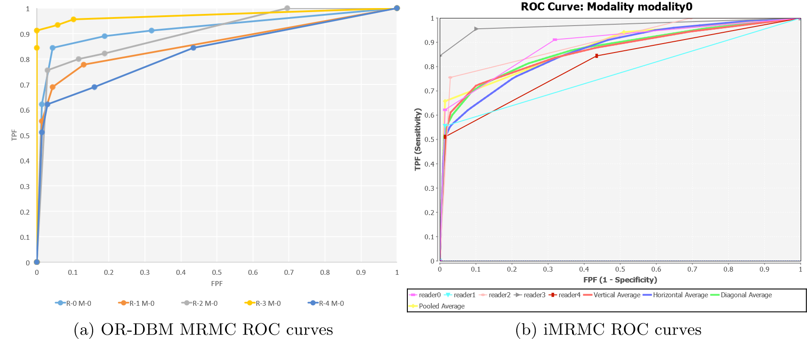

Figure 2: Empirical ROC curves output of OR-DBM MRMC and iMRMC

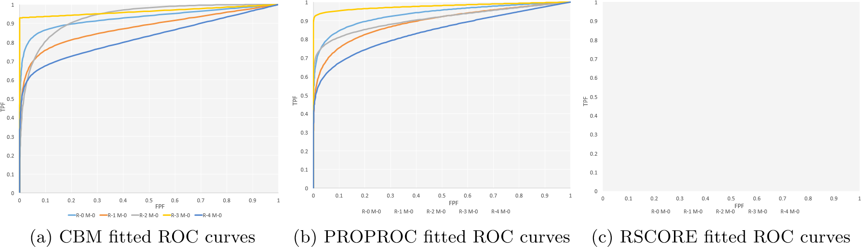

Figure 3: Fitted ROC Curves Plots

Table 6 contains the results of sample size calculation. Sample size (number of readers and cases) are estimated using JAFROCwR in the condition that significance level equals 0.05, effect size equals 0.05 and desired power equals 0.8. Then iMRMC is used to calculate the statistical power using corresponding sample size. The results are still slightly different due to the different estimation of variance components.

# 4. Additional Features of JAFROCwR

Table 6: Sample Size Calculation

|  |  |  |  |  |  |
| --- | --- | --- | --- | --- | --- |
| JAFROCwR | |  | iMRMC | |  |
| # of Readers | # of Cases | Power | # of Readers | # of Cases | Power |
| 5 | 213 | 0.80 | 5 | 213 | 0.79 |
| 6 | 170 | 0.80 | 6 | 170 | 0.80 |
| 7 | 148 | 0.80 | 7 | 148 | 0.80 |
| 8 | 134 | 0.80 | 8 | 134 | 0.80 |
| 9 | 125 | 0.80 | 9 | 125 | 0.82 |
| 10 | 119 | 0.80 | 10 | 119 | 0.82 |

However, the radiologists’ task is actually more than simply giving a single abnormality. In clinical situations, the lesion localizations (where it is) are required sometimes. It is important to indicate the radiologists’ capability both to detect and locate the lesions. In this case, some statistical approaches are proposed to analyze the performance on detecting and locating the lesions including localization ROC (LROC) (Starr, Metz, Lusted, and Goodenough 1975; Swensson 1996), region of interest (ROI) Obuchowski, Lieber, and Powell (2000); Rutter (2000) and free-response ROC (FROC) (Miller 1969; Bunch, Hamilton, Sanderson, and Simmons 1977; Chakraborty, Breatnach, Yester, Soto, Barnes, and Fraser 1986; Chakraborty 1989). These localization approaches are also implemented in JAFROCwR. Some figures of merit has been defined so DBM and OR method can be used for lesion localizations analysis. In LROC approach, the reader gives a single rating to each case and marks the suspicious region. The rating is regarded as a true positive if and only if the corresponding suspicious region is marked correctly. Otherwise, the rating is treated as a false positive. ROI and FROC approaches are introduced in following subsections.

4.1. ROI and FROC Figures of Merit Used in JAFROCwR

## Notation

For ROI and FROC study, lesion localization is taken into consideration. Hence more than one marks are allowed for each case. Let *kt* denote the index of cases where t indicates the disease-status at the case (or patient) level, with *t* = 1 for non-diseased cases and *t* = 2 for diseased cases; *k*1 ranges from 1 to *K*1 for non-diseased cases and *k*2 ranges from 1 to *K*2 for diseased cases. Marks are indexed by *ls* where *s* indicates the truth at the location level, with *s* = 1 for a non-lesion localization and *s* = 2 for a lesion localization; *l*1 = 1*,*2*,...*, indexes marks of type *s* = 1 and *l*2 = 1*,*2*,...*, *nk*2, indexes marks of type *s* = 2, where *Nk*2 is the number of lesions visible in image *k*2. *Zktls* denotes the rating of mark *ls* on case *kt*. *Zk*2*l*2 is assigned −∞ if the corresponding lesion localization is unmarked.

## ROI Figure of Merit

In the ROI paradigm the investigator segments the image into a number of regions of interest (ROIs) and the radiologist rates each ROI for presence of at least one lesion somewhere within the ROI. The data consisted of a rating for each ROI. The ROI figure of merit *θijROI* is defined by (Obuchowski *et al.* 2000)

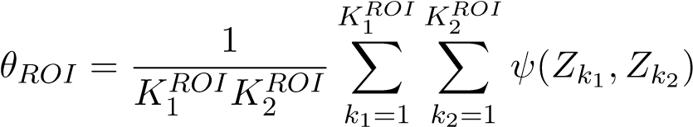

where *ψ* is the function defined by equation  is the number of non-diseased ROIs and  is the number of diseased ROIs, ) and) are the ratings for corresponding ROIs.

## FROC Figures of Merit

The free-response receiver operating characteristic analysis takes marks localization into account. In the free-response paradigm, the radiologist is free to mark and rate more than one suspicious regions that are considered. In this case, the number of marks is also regarded as a random variable. This source of randomness is the main difficulty of FROC analysis. Some commonly used FROC figures of merit are defined as follows (Chakraborty and Berbaum 2004; Song, Bandos, Rockette, and Gur 2008).

The weighted JAFROC figure of merit is defined by (the superscript *c* denotes case-based)

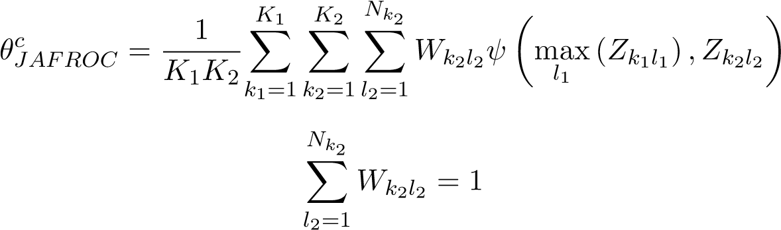

where *ψ* is the function defined by equation 1, max*ls* (*Zktls*) is the maximum over the ratings of all *s* localizations on the case *kt* and *Wk*2*l*2 is the weight of lesion *l*2 in diseased case *k*2. The un-weighted JAFROC figure of merit is defined by (the superscript *l* denotes lesion-based)

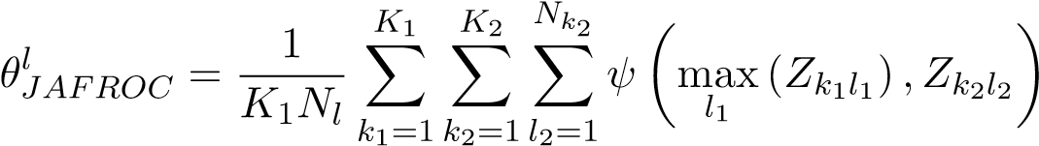

where *Nl* is the total number of lesions in all diseased cases by definition

*K*2

*Nl* = X *Nk*2

*k*2=1

The weighted JAFROC1 figure of merit is defined by

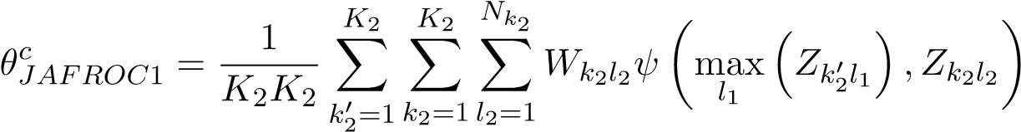

The un-weighted JAFROC1 figure of merit is defined by

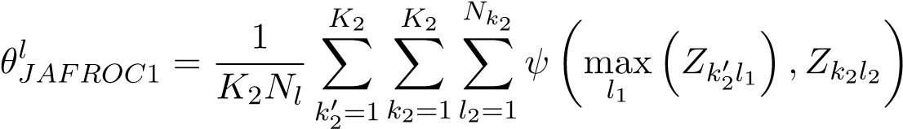

The inferred-ROC figure of merit is defined by (the superscript i denotes inferred)

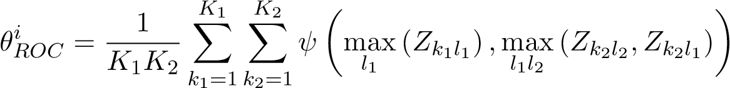

The maximum lesion localization fraction figure of merit is defined by

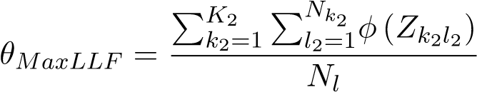

where *φ* is a function given by

*Z* is − ∞

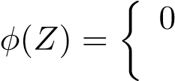 1 otherwise

The maximum non-lesion localization fraction figure of merit is defined by

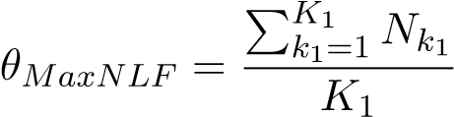

where *Nk*1 denotes the number of non-lesion localization marks in case *k*1.

The maximum non-lesion localization fraction for all cases figure of merit is defined by

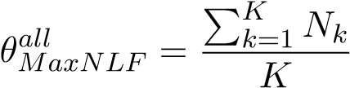

where *Nk* denotes the number of non-lesion localization marks in case *k*. The exponential transformed specificity figure of merit is defined by

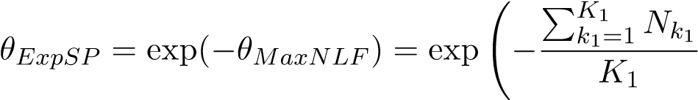!

The Song figures of merit A0, A1 and A2 are also used in JAFROCwR. They are defined in Song *et al.* (2008).

### 4.2. ROC/AFROC/FROC Plots

Empirical and parametric ROC/AFROC/FROC curves can be plotted using functions in JAFROCwR. These curves are defined as follows.

## Empirical Plots

The ROC curve is a plot of true positive fraction (*TPF*) vs. false positive fraction (*FPF*), where *TPF* = number of positive decisions / number of diseased cases and *FPF* = number of positive decisions / number of non-diseased cases. For FROC data, *TPF* and *FPF* are calculated using the inferred ROC data by highest rating assumption. The AFROC curve is a plot of lesion localization fraction (*LLF*) vs. *FPF*, where *LLF* = number of lesions localizations / the total number of lesions. The FROC curve is a plot of *LLF* vs. non-lesion localization fraction (*NLF*), where *NLF* = number of non-lesion localizations / the number of cases.

## Parametric Plots

Parametric ROC/AFROC/FROC curves are parametric predicted (fitted) curves using search model, which are defined in subsection 4.3. The steps that fit the curves are also given in that part.

### 4.3. Search-Model

The search-model (Chakraborty 2006a,b) is used to estimate sample size and fit ROC and (A)FROC curves for FROC data in JAFROCwR. According to Kundel and Nodine (Kundel and Nodine 1983, 2004; Kundel, Nodine, Conant, and Weinstein 2007; Nodine and Kundel 1987), image interpretation involves a search stage and a decision-making stage. During the search stage the radiologist quickly identifies suspicious regions. The search-stage is characterized by a random number of suspicious regions. During the decision making stage the observer calculates a rating at each suspicious region, and if it exceeds the minimum reporting threshold the region is marked.

Suspicious regions are termed *noise-sites* or *signal-sites* for benign tumors or lesions, respectively. The number of noise-sites on an image is assumed to be sampled from a Poisson distribution with mean *λ*. The number of signal-sites on a diseased image is assumed to be sampled from a binomial distribution with success probability *ν* and the total number of lesions on the diseased case *k*2. The ratings form noise-site is assumed sampled from a normal distribution *N*(0*,*1) and that from signal-site is assumed sampled from *N*(*µ,*1).

## Search-model predicted ROC curves

The ROC curve of FROC data can be inferred using the highest rating assumption. The ROC curve predicted by the search-model is defined by (Chakraborty 2006a)

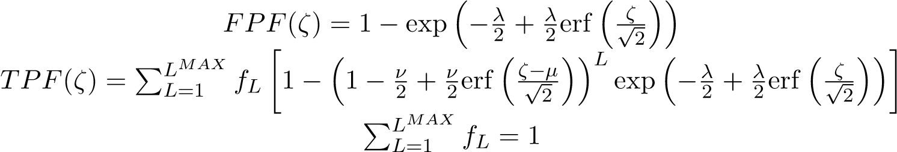 (4)

where *ζ* is the cutoff parameter determining an operating point on the ROC curve, *L* is the number of lesions in a diseased case, *fL* is the fraction of diseased cases with *L* lesions, and erf(*x*) is the error function defined in Press (2007, p. 1235). *TPF*(*ζ*) is a weighted average of true positive fraction for cases with *L* = 1*,*2*,...,LMAX* lesions.

## Search-model predicted AFROC curves

The expression for the FPF predicted by the search-model has already been given in equation 4. That for the lesion localization fraction (LLF) is (Chakraborty and Yoon 2008)

LMAX

*LLF*(*ζ*) = X *fL* [*ν* (1 − Φ(*ζ* − *µ*))] = *ν* (1 − Φ(*ζ* − *µ*)) (5)

*L*=1

where Φ(*ζ*) is the cumulative distribution function (CDF) of standard normal distribution.

## Search-model predicted FROC curves

The expression for the LLF predicted by the search-model has already been given in equation 5. That for the non-lesion localization fraction (NLF) is (Chakraborty and Yoon 2008)

*NLF*(*ζ*) = *λ*(1 − Φ(*ζ*)) (6)

Likelihood functions are defined to fit the ROC/AFROC/FROC curves using search-model.

## ROC likelihood function

Let (*Fb,Tb*) denote the number of false positive and true positives, respectively, in ratings bin *b* defined by neighboring cutoffs (*ζb,ζb*+1), where *b* = 0*,*1*,...,R* where *R* is the number of bins, and *ζ*0 = −∞ and *ζR*+1 = +∞. For example, *F*0 and *T*0 represent the number of non-diseased and diseased cases with no marks respectively. The contribution of the ROC likelihood function from bin *b* is

LROCb = [FPF(ζb) − FPF(ζb+1)]Fb[TPF(ζb) − TPF(ζb+1)]Tb (7)

The net likelihood L*ROC* is the product of the ROC likelihood function from all *R* + 1 bins,

R

LROC = YLROCb

*b*=0

## AFROC likelihood function

Let (*Fb,Lb*) denote the number of false positive and lesion localizations, respectively, in bin *b* between neighboring cutoffs (*ζb,ζb*+1). The contribution of the AFROC likelihood function from bin *b* is

LAFROCb = [FPF(ζb) − FPF(ζb+1)]Fb[LLF(ζb) − LLF(ζb+1)]Lb (8)

## FROC likelihood function

Let (*Nb,Lb*) denote the number of non-lesion localizations and lesion localizations, respectively, in bin *b* between neighboring cutoffs (*ζb,ζb*+1). The contribution of the FROC likelihood function from bin *b* is

LFROCb = [NLF(ζb) − NLF(ζb+1)]Nb[LLF(ζb) − LLF(ζb+1)]Lb (9)

→−

To fit the curve, we need to estimate parameters *λ*, *ν*, *ζ* and *µ* that maximize the logarithm of the likelihood 7, 8 and 9. Following algorithm is used in JAFROCwR to estimate the search-model parameters of fitted ROC/AFROC/FROC curves.

→−

1. For given *λ*, *ν* and cutoffs *ζ* , determine *µ* by minimizing the Chi-square goodness of fit statistic
2. Calculate the logarithm of corresponding likelihood.

→−

1. Repeat preceding steps using varied *λ*, *ν* and *ζ* until reach the maximum.

4.4. FROC Example

## ROI and FROC Analysis

ROI and FROC data file are able to be analyzed by JAFROCwR using figures of merit that were mentioned in subsection 4.1. The usage of functions for ROI/FROC data analysis are same as that for ROC analysis. Note that only ”ROI” figure of merit is available for ROI data. For FROC data, empirical and search model parametric ROC/AFROC/FROC curves are available. Figure 4, 5 and 6 are the empirical and parametric ROC/AFROC/FROC curves.

> frocData <- readJAFROC("frocDataFile.xls")

> rocCurve <- plotROC(data = frocData, plottingModalities = 1,

+ plottingReaders = list(1, 2, 3, 4, 5, c(1:5)),

+ legendPosition = "bottom")

> fittedRocCurve <- plotFittedROCCurve(data = frocData, plottingModalities = 1,

+ plottingReaders = list(1, 2, 3, 4, 5, c(1:5)),

+ legendPosition = "bottom")

> multiplot(rocCurve$ROCPlot, fittedRocCurve$ROCPlot, cols = 2)

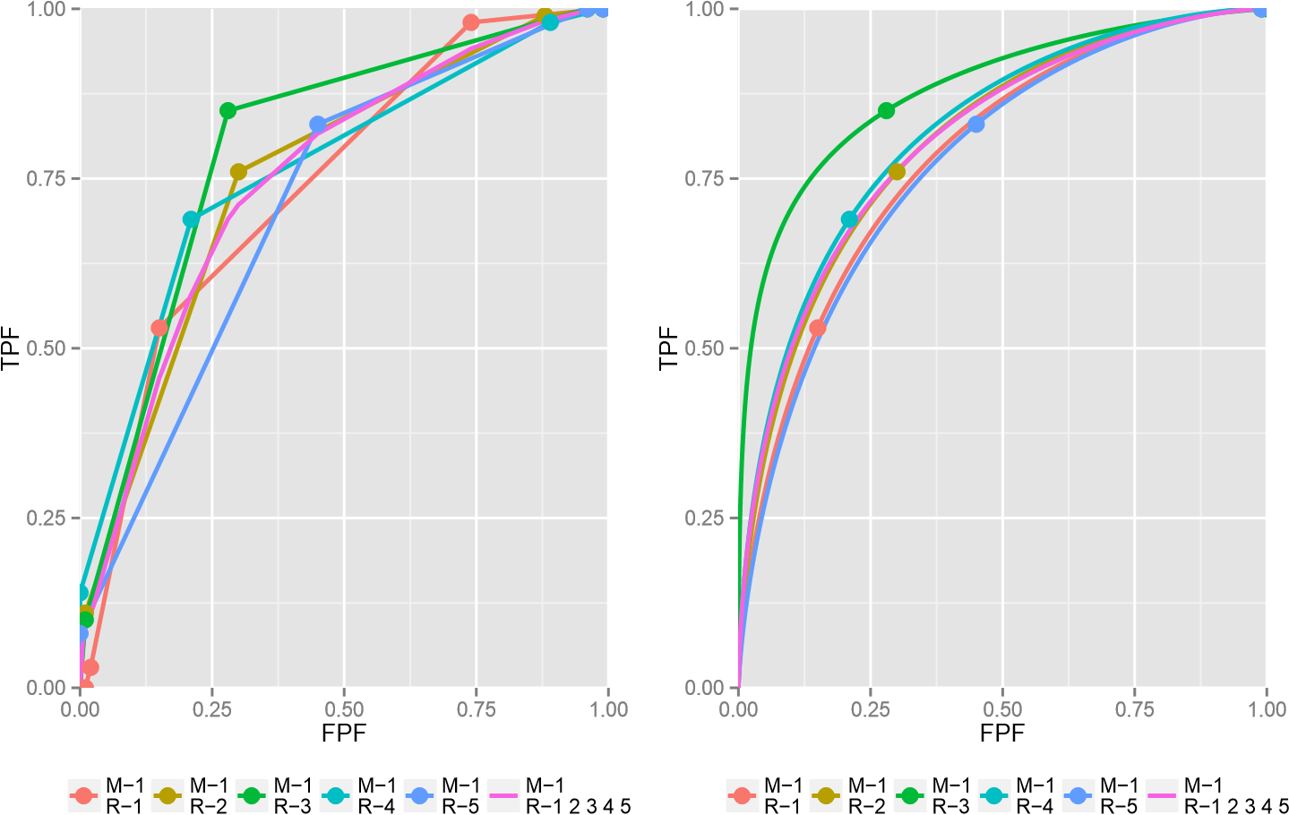

Figure 4: Plots of empirical (left) and fitted (right) ROC curves of each reader and their average performance using modality 0

> afrocCurve <- plotAFROC(data = frocData, plottingModalities = 1,

+ plottingReaders = list(1, 2, 3, 4, 5, c(1:5)),

+ legendPosition = "bottom")

> fittedAfrocCurve <- plotFittedAFROCCurve(data = frocData, plottingModalities = 1,

+ plottingReaders = list(1, 2, 3, 4, 5, c(1:5)),

+ legendPosition = "bottom")

> multiplot(afrocCurve$AFROCPlot, fittedAfrocCurve$AFROCPlot, cols = 2)

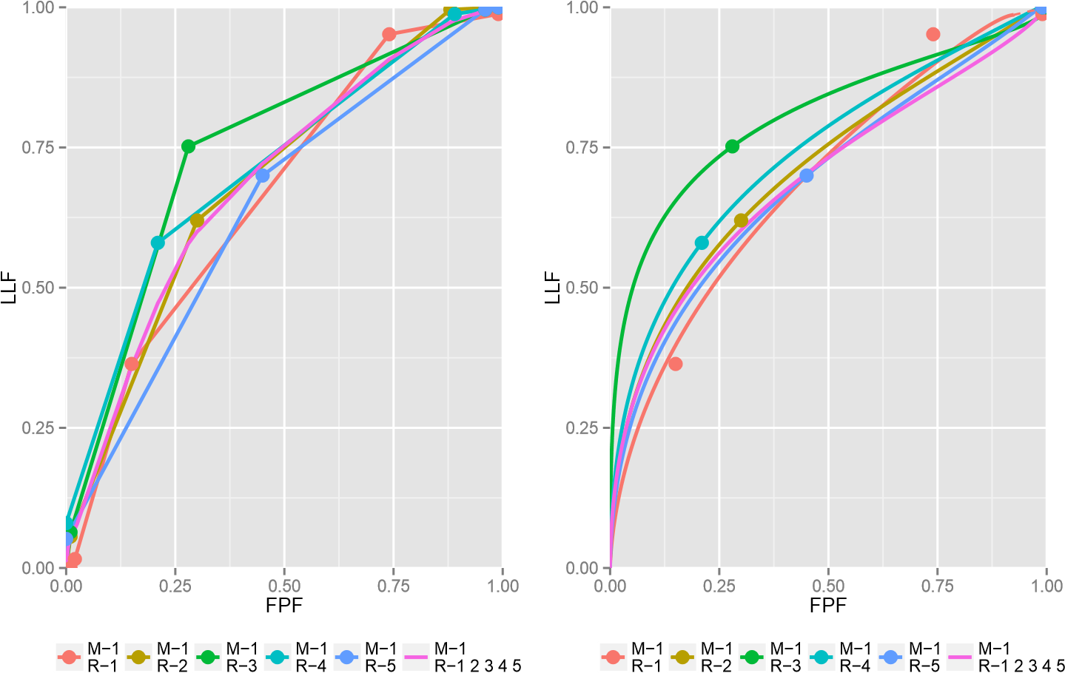

Figure 5: Plots of empirical (left) and fitted (right) AFROC curves of each reader and their average performance using modality 0

> frocCurve <- plotFROC(data = frocData, plottingModalities = 1,

+ plottingReaders = list(1, 2, 3, 4, 5, c(1:5)),

+ legendPosition = "bottom")

> fittedFrocCurve <- plotFittedFROCCurve(data = frocData, plottingModalities = 1,

+ plottingReaders = list(1, 2, 3, 4, 5, c(1:5)),

+ legendPosition = "bottom")

> multiplot(frocCurve$FROCPlot, fittedFrocCurve$FROCPlot, cols = 2)

## Sample Size Estimation for FROC Data

For FROC data, sample size estimation can be performed using similar methods. Details are described in Chakraborty (2011). In short, estimate the search-model parameters of pilot study, then use them to calculate the area under ROC curve by numerical integration of the predicted ROC curve (equation 4). Add the desired ROC effect size, and new values of parameters can be determined. Calculate effect size in JAFROC unit with these new parameters. Finally, required sample size to achieve the JAFROC unit effect size and statistical power can be estimated using same steps for ROC sample size estimation.

## Operating Characteristics

Operating characteristics function provides the ability to input specific values for the search model parameters to visualize the effects on the predicted ROC, AFROC and FROC curves.

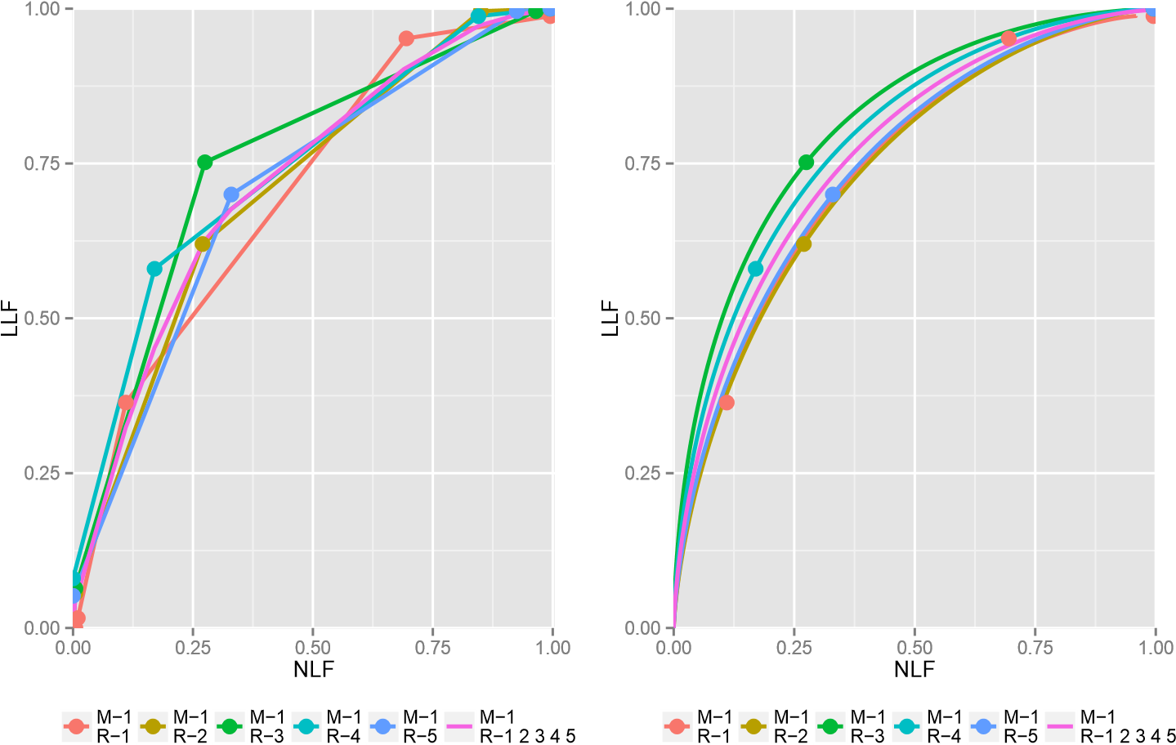

Figure 6: Plots of empirical (left) and fitted (right) FROC curves of each reader and their average performance using modality 0

It is a convenient tool to understand how changes in reader characteristics (parameters are defined in subsection 4.3) affect reader performance. The function accommodates one or more modalities and varying number of lesions per case and calculates ROC and AFROC areas for all modalities. Figure 7 shows example plots for *µ* = 2, *λ* = 1, *ν* = 0.6, 30 single-lesioncases and 35 two-lesion-cases in the NH modality and *µ* = 3 in AH modality. The four plots show how *µ* affects the observer’s performance. Other parameters’ effects can be studied by changing and compare the plots.

> lesionNumList <- list(rbind(c(1, 30), c(2, 35)),

+ rbind(c(1, 30), c(2, 35)))

> oprtChrctResults <- operatingCharacteristics(mu = c(2, 3), lambda = c(1, 1),

+ nu = c(0.6, 0.6),

+ lesionNumTable = lesionNumList,

+ legendPosition = "bottom")

> oprtChrctResults$aucROC

[1] 0.8279472 0.8562302

> oprtChrctResults$aucJAFROC

[1] 0.6323901 0.6641375

> multiplot(oprtChrctResults$ROCPlot, oprtChrctResults$FROCPlot,

+ oprtChrctResults$AFROCPlot, oprtChrctResults$PDFPlot, cols = 2)

# 5. Discussion

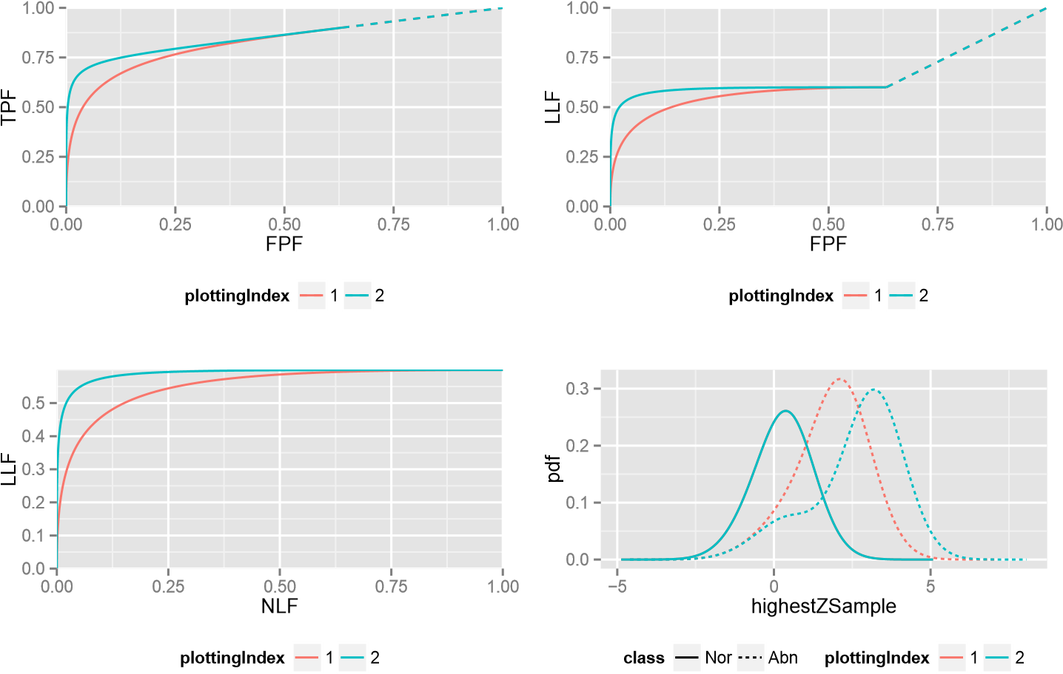

Figure 7: Operating Characteristics curves for *µ* = 2, *λ* = 1, *ν* = 0.6 (red) and *µ* = 3, *λ* = 1, *ν* = 0.6 (green)

Compared with iMRMC and OR-DBM MRMC, advantages and limitations of JAFROCwR are summed up in following parts.

## **5.1. Advantages of** JAFROCwR

In summary, JAFROCwR performs better than the others in following aspects.

1. *Programmabilty*. Both of OR-DBM MRMC and iMRMC are GUI-based softwares, so it is almost impossible to call them and catch the results from users’ own program. JAFROCwR is distributed as a package of R. All functions in the package can be used in users’ own R code. Considering the good interactivity between R and other programming languages, JAFROCwR can also be easily called from programming environments other than R including but not limited to C/C++, Java, Python and MATLAB. In additional, JAFROCwR is an open source package. Users can find the source code of the package online, and it is convenient to debug and modify the source code if the original version cannot meet users’ specific requirements.
2. *Ability to Analyze Localization Data*. JAFROC and JAFROCwR are the only available software for free-response studies, and JAFROCwR implements OR method for FROC data for the first time. Operating Characteristics is a useful tool to help users understand the effect of FROC parameters.
3. *Plotting Features* JAFROCwR provides empirical and search model fitted parametric ROC/AFROC/FROC curves. The R package ggplot2 (Wickham 2009) is used to plot all these curves. It gives fancy layouts, colors and legends, and ggplot2 objects are easy

to be modified. Both the plotting data points and ggplot2 objects are returned. Users can output the data points then plot the curves using other tools, or modify the ggplot2 object as their own requirements.

## **5.2. Limitations and Potential Future Updates**

JAFROCwR has limitations need to be improved in the future. There are also some more features should be useful to be added in the package. General ideas are given as follows.

1. *Running Speed*. Since all the code of JAFROCwR are written using R and a lot of resampling operations (jackknife and bootstrap) are implemented by loops, the running time, especially for larger data file, is longer than that of the softwares written using “lower-level”languages such as C/C++. We are considering that convert some functions with many loop operations to C/C++ in the future. In the data import part, xlsx is used to read Excel file. The package provides the capibility to handle the operations to Excel fiel, but the running speed is slow. We are looking for a replacement of xlsx (Dragulescu 2014) to reduce the data reading time.
2. *Other Figure of Merit and Methods*. Only AUC is used as the ROC analysis figure of merit and only search model is used to fit the curves. Other figure of merit and model should also be implemented and included in the future.
3. *Simulator*. Simulation plays an important role in ROC/FROC researches. It is always used to validate a new statistical method. Hence the simulator design is very significant. We are planning to provide a simulator in JAFROCwR to help users generate simulation data.
4. *Graphical User Interface*. GUI is necessary for some users, especially for the old users of JAFROC. An R based GUI package for JAFROCwR is in development. We will publish it when it is finished. JAFROC can be completely replaced at that time.

# 6. Conclusions

The JAFROCwR package is able to perform MRMC analysis of ROC/FROC/ROI data. The package provides OR and DBM methods for performing MRMC analysis, each of which can be used with different figures of merit. Sample size calculation helps to estimate sample size for given effect size and statistical power in future study. Through the cross validation between the analysis of same dataset by JAFROCwR and other softwares, the analysis results of JAFROCwR is reliable.

Empirical and parametric ROC/AFROC/FROC curves are also given by the package. Search model is used to fit the curves. Operating Characteristics shows the effect of search model parameters on the predicted ROC, AFROC and FROC curves. It is convenient to demonstrate how the parameters affect readers’ performance.

Through the provided examples, JAFROCwR will be definitely helpful if you are using R as a main programming language. Future version of this package will attempt to reduce the running time as well as provide more features.

# References

Brandon D Gallas Xin He RP (2014). *iMRMC User Manual Version 2.2*. URL [https:](https://code.google.com/p/imrmc/)

[//code.google.com/p/imrmc/.](https://code.google.com/p/imrmc/)

Bunch PC, Hamilton JF, Sanderson GK, Simmons AH (1977). “A free response approach to the measurement and characterization of radiographic observer performance.” In *Application of Optical Instrumentation in Medicine VI*, pp. 124–135. International Society for Optics and Photonics.

Chakraborty D (2006a). “ROC curves predicted by a model of visual search.” *Physics in medicine and biology*, **51**(14), 3463.

Chakraborty D (2006b). “A search model and figure of merit for observer data acquired according to the free-response paradigm.” *Physics in medicine and biology*, **51**(14), 3449.

Chakraborty D, Yoon HJ (2008).“Operating characteristics predicted by models for diagnostic tasks involving lesion localization.” *Medical physics*, **35**(2), 435–445.

Chakraborty DP (1989). “Maximum likelihood analysis of free-response receiver operating characteristic (FROC) data.” *Medical physics*, **16**(4), 561–568.

Chakraborty DP (2011).“New developments in observer performance methodology in medical imaging.” In *Seminars in nuclear medicine*, volume 41, pp. 401–418. Elsevier.

Chakraborty DP, Berbaum KS (2004). “Observer studies involving detection and localization: modeling, analysis, and validation.” *Medical physics*, **31**(8), 2313–2330.

Chakraborty DP, Breatnach ES, Yester MV, Soto B, Barnes G, Fraser R (1986). “Digital and conventional chest imaging: a modified ROC study of observer performance using simulated nodules.” *Radiology*, **158**(1), 35–39.

DeLong ER, DeLong DM, Clarke-Pearson DL (1988).“Comparing the areas under two or more correlated receiver operating characteristic curves: a nonparametric approach.” *Biometrics*, pp. 837–845.

Dorfman DD, Alf E (1969).“Maximum-likelihood estimation of parameters of signal-detection theory and determination of confidence intervals—rating-method data.” *Journal of mathematical psychology*, **6**(3), 487–496.

Dorfman DD, Berbaum KS (1995). “Degeneracy and discrete receiver operating characteristic rating data.” *Academic Radiology*, **2**(10), 907–915.

Dorfman DD, Berbaum KS (2000a). “A contaminated binormal model for ROC data: Part II. A formal model.” *Academic radiology*, **7**(6), 427–437.

Dorfman DD, Berbaum KS (2000b). “A contaminated binormal model for ROC data: Part III. Initial evaluation with detection ROC data.” *Academic radiology*, **7**(6), 438–447.

Dorfman DD, Berbaum KS, Brandser EA (2000). “A contaminated binormal model for ROC data: Part I. Some interesting examples of binormal degeneracy.” *Academic radiology*, **7**(6), 420–426.

DORFMAN DD, BERBAUM KS, METZ CE (1992).“Receiver Operating Characteristic Rating Analysis: Generalization to the Population of Readers and Patients with the Jackknife Method.” *Investigative radiology*, **27**(9), 723–731.

Dragulescu AA (2014). xlsx: Read, write, format Excel 2007 and Excel 97/2000/XP/2003 files. R package version 0.5.7.

Efron B, Stein C (1981). “The jackknife estimate of variance.” *The Annals of Statistics*, pp. 586–596.

Hillis SL (2007). “A comparison of denominator degrees of freedom methods for multiple observer ROC analysis.” *Statistics in medicine*, **26**(3), 596–619.

Hillis SL, Obuchowski NA, Berbaum KS (2011). “Power estimation for multireader ROC methods: an updated and unified approach.” *Academic radiology*, **18**(2), 129–142.

Hillis SL, Obuchowski NA, Schartz KM, Berbaum KS (2005). “A comparison of the Dorfman– Berbaum–Metz and Obuchowski–Rockette methods for receiver operating characteristic (ROC) data.” *Statistics in medicine*, **24**(10), 1579–1607.

Kundel H, Nodine C (1983). “A visual concept shapes image perception.” *Radiology*, **146**(2), 363–368.

Kundel HL, Nodine CF (2004). “Modeling visual search during mammogram viewing.” In *Medical Imaging 2004*, pp. 110–115. International Society for Optics and Photonics.

Kundel HL, Nodine CF, Conant EF, Weinstein SP (2007). “Holistic component of image perception in mammogram interpretation: gaze-tracking study 1.” *Radiology*, **242**(2), 396– 402.

Metz CE, Pan X (1999). ““Proper” binormal ROC curves: theory and maximum-likelihood estimation.” *Journal of mathematical psychology*, **43**(1), 1–33.

Miller H (1969). “The FROC curve: a representation of the observer’s performance for the method of free response.” *The Journal of the Acoustical Society of America*, **46**(6B), 1473– 1476.

Nodine CF, Kundel HL (1987). “Using eye movements to study visual search and to improve tumor detection.” *Radiographics*, **7**(6), 1241–1250.

Obuchowski NA, Lieber ML, Powell KA (2000). “Data analysis for detection and localization of multiple abnormalities with application to mammography.” *Academic radiology*, **7**(7), 516–525.

Obuchowski Jr NA, Rockette Jr HE (1995). “Hypothesis testing of diagnostic accuracy for multiple readers and multiple tests an anova approach with dependent observations.” *Communications in Statistics-Simulation and Computation*, **24**(2), 285–308.

Pan X, Metz CE (1997). “The “proper” binormal model: parametric receiver operating characteristic curve estimation with degenerate data.” *Academic radiology*, **4**(5), 380–389.

Pesce LL, Metz CE (2007). “Reliable and computationally efficient maximum-likelihood estimation of “proper” binormal ROC curves.” *Academic radiology*, **14**(7), 814–829.

Press WH (2007). Numerical recipes 3rd edition: The art of scientific computing. Cambridge university press.

Rutter CM (2000). “Bootstrap estimation of diagnostic accuracy with patient-clustered data.” *Academic radiology*, **7**(6), 413–419.

Song T, Bandos AI, Rockette HE, Gur D (2008). “On comparing methods for discriminating between actually negative and actually positive subjects with FROC type data.” *Medical physics*, **35**(4), 1547–1558.

Starr SJ, Metz CE, Lusted LB, Goodenough DJ (1975). “Visual Detection and Localization of Radiographic Images 1.” *Radiology*, **116**(3), 533–538.

Stephen L Hillis Kevin M Schartz KSB (2014). *OR-DBM MRMC 2.5 User Guide*. URL [http://perception.radiology.uiowa.edu/Software/](http://perception.radiology.uiowa.edu/Software/ReceiverOperatingCharacteristicROC/MRMCAnalysis/tabid/116/Default.aspx)

[ReceiverOperatingCharacteristicROC/MRMCAnalysis/tabid/116/Default.aspx.](http://perception.radiology.uiowa.edu/Software/ReceiverOperatingCharacteristicROC/MRMCAnalysis/tabid/116/Default.aspx)

Swensson RG (1996). “Unified measurement of observer performance in detecting and localizing target objects on images.” *Medical physics*, **23**(10), 1709–1725.

Van Dyke C, White R, Obuchowski N, Geisinger M, Lorig R, Meziane M (1993). “Cine MRI in the diagnosis of thoracic aortic dissection. 79th RSNA Meetings.” *Chicago, IL*, **28**.

Wickham H (2009). *ggplot2: elegant graphics for data analysis*. Springer Science &amp; Business Media.

Affiliation:

Xuetong Zhai

Department of Radiology

University of Pittsburgh

Pittsburgh, PA 15213

United States of America E-mail: xuz19@pitt.edu

|  |  |
| --- | --- |
| Journal of Statistical Software | <http://www.jstatsoft.org/> |
| published by the American Statistical Association | <http://www.amstat.org/> |
| Volume VV, Issue II | Submitted: yyyy-mm-dd |
| MMMMMM YYYY | *Accepted:* yyyy-mm-dd |